



**TECHNOLOGY INFRASTRUCTURE**

Lesson3: How Websites work



GETTING ASSISTANCE

By now the majority of you have interacted with fellow classmates. Others have been using the internet as a key source for further knowledge apart from the lecturers. I encourage you to try all the different ways which can be used for furthering your knowledge.

SO WHAT DO YOU NEED FOR THIS MODULE?

For this module, you need to have mastered concepts on computer networking together with the tech ecosystem. In addition, the Internet protocols explained in the previous lesson is supposed to help you understand the concept on how websites better.

So let us get started 

**Introduction**

With the massive improvements in technology and innovation, businesses have adopted new ways of communicating with their customers and or new ways of communicating with their customers. One of the ways used by organisations to communicate with their customers is by utilising the internet using websites. This way of communicating is cheap, fast and reliable. Well you might be wondering - Is there any difference between websites and internet? To address this question, lest start by defining the key terms.

**Terminology**

Often, people tend to confuse the terms internet and web.

***The Internet*** is a global network of networks while ***the Web***, also referred formally as World Wide Web (www) is collection of information which is accessed via ***the Internet***. Another way to look at this difference is; ***the Internet*** is infrastructure while ***the Web*** is service on top of that infrastructure. The web is a subset of the internet.

The content on the Web is available because the Web is a network of computers all over the world. The interconnected devices on the Web use a communication standard known as http (hypertext transfer protocol) to view content on the website. A website is a collection of web pages which are grouped together and usually connected together in various ways. Often called a "web site" or simply a "site”.

Computers connected to the web are called **clients**and **servers**. Clients are the typical web user's internet-connected devices. Web server is a computer that hosts a website on the Internet. Web servers are computers whose job is to respond to a browser’s request for a web page and deliver it through the internet.

**A web server**is [server software](https://en.wikipedia.org/wiki/Server_software), or hardware dedicated to running said software, that can satisfy [World Wide Web](https://en.wikipedia.org/wiki/World_Wide_Web) client requests. A web server can, in general, contain one or more [websites](https://en.wikipedia.org/wiki/Website). A web server processes incoming [network](https://en.wikipedia.org/wiki/Computer_network) requests over [HTTP](https://en.wikipedia.org/wiki/Hypertext_Transfer_Protocol) and several other related [protocols](https://en.wikipedia.org/wiki/Communication_protocol).

The primary function of a web server is to store, process and deliver [web pages](https://en.wikipedia.org/wiki/Web_page) to [clients](https://en.wikipedia.org/wiki/Client_(computing)). The communication between client and server takes place using the [Hypertext Transfer Protocol (HTTP)](https://en.wikipedia.org/wiki/Hypertext_Transfer_Protocol). Pages delivered are most frequently [HTML documents](https://en.wikipedia.org/wiki/HTML), which may include [images](https://en.wikipedia.org/wiki/Image), [style sheets](https://en.wikipedia.org/wiki/Style_sheet_(web_development)) and [scripts](https://en.wikipedia.org/wiki/JavaScript) in addition to the text content. These HTML documents are rendered through a web browser.

**Web browsers**- A web browser (commonly referred to as a browser) is a software application for accessing information on the World Wide Web. Figure 1 provides you with examples of common browsers. These are not the only ones and perhaps not the best. The choice depends on the user expectations.

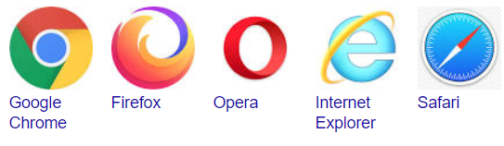

**Figure 1:Common examples of web browsers**

So you can connect to the internet to search through the web using the web browser to view the website, or just using the internet to connect with anyone in the world. The possibilities online are endless.

Before we explain how the webpage or site gets displayed, let us move on and explain key terms that you will help understand the process of getting content displayed.

**TCP/IP**: Transmission Control Protocol and Internet Protocol are communication protocols that define how data should travel across the web. This is like the transport mechanisms that let you place an order, go to the shop, and buy your goods. In our example, this is like a car or a bike (or however else you might get around).

**DNS**: Domain Name Servers are like an address book for websites. When you type a web address in your browser, the browser looks at the DNS to find the website's real address before it can retrieve the website. The browser needs to find out which server the website lives on, so it can send HTTP messages to the right place (see below). This is like looking up the address of the shop so you can access it.

**HTTP**: Hypertext Transfer Protocol is an application [protocol](https://developer.mozilla.org/en-US/docs/Glossary/Protocol) that defines a language for clients and servers to speak to each other. This is like the language you use to order your goods. Remember, in lesson 2, we discussed the Open Systems Interconnection reference model and HTTP was identified as a Layer 7 (Application Layer) protocol. Majority of websites which display public information use HTTP. If there is private data, organisations use Hypertext Transfer Protocol Secure (HTTPs) protocol.

**How does the website work?**

Let us look at the diagram below detailing how websites work.

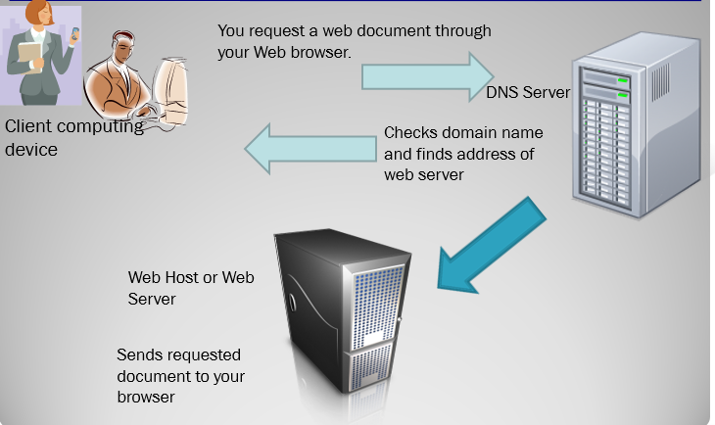

**Processes explained.**

When you type a web address into your browser (for our analogy that's like walking to the shop):

1. The browser goes to the DNS server, and finds the real address of the server that the website lives on (you find the address of the shop).
2. The browser sends an HTTP request message to the server, asking it to send a copy of the website to the client (you go to the shop and order your goods). This message, and all other data sent between the client and the server, is sent across your internet connection using TCP/IP.
3. If the server approves the client's request, the server sends the client a "200 OK" message, which means "Of course you can look at that website! Here it is", and then starts sending the website's files to the browser as a series of small chunks called data packets (the shop gives you your goods, and you bring them back to your house).
4. The browser assembles the small chunks into a complete website and displays it to you (the goods arrive at your door — new shiny stuff, awesome!).

**Understanding ISP**

Ok so now you are going to be developing websites for yourself or for an organisation. Have you ever thought how you going to have them online or even how you going to get access to your internet?

An ISP (Internet service provider) is a company that provides individuals and other companies access to the Internet and other related services such as Web site building and virtual hosting. Internet Service Providers assign static IP address to an organization. It is assigned by the Internet Service Provider as a permanent address. Dynamic IP is the temporary IP address assigned by the network to a computing device. Dynamic IP is automatically assigned by the server to the network device.

An ISP has the equipment and the telecommunication line access required to have a point-of-presence on the Internet for the geographic area served. The larger ISPs have their own high-speed leased lines so that they are less dependent on the telecommunication providers and can provide better service to their customers. Among the largest national and regional ISPs are AT&T WorldNet, IBM Global Network, MCI, Netcom, UUNet, and PSINet.

Some of the common services offered by internet service providers include:

* internet access
* email access
* domain name registration
* web hosting
* co-location (or data center services)

In providing services to their customers, many internet service providers (ISPs) introduce **service level agreements** against their offerings (Uptime)

So what are the available connection options for Internet Service Providers?

**Internet Service Providers Connection Options**

**Dial-Up**-Slowest and least expensive

**Cell modem** - Available through cellular telephone providers

**Digital Subscriber Line (DSL)-** high speed digital connection over regular telephone line

**Cable Modem-**High speed connection over the cable TV network. Through the use of a [cable modem](https://www.webopedia.com/TERM/C/cable_modem.html) you can have a broadband Internet connection that is designed to operate over cable TV lines. Cable Internet works by using TV channel space for data transmission, with certain channels used for downstream transmission, and other channels for upstream transmission.

**Leased lines-** available for most telephone companies. An example is T-1 leased lines. [T-1 lines](https://www.webopedia.com/TERM/T/T_1_carrier.html) are a popular leased line option for businesses connecting to the Internet and for Internet Service Providers (ISPs) connecting to the Internet backbone. It is a dedicated phone connection supporting data rates of 1.544Mbps.  A T-1 line actually consists of 24 individual channels, each of which supports 64Kbits per second.

**Satellite** - [Internet over Satellite](https://www.webopedia.com/TERM/I/IoS.html)(IoS) allows a user to access the Internet via a satellite that orbits the earth. A satellite is placed at a static point above the earth's surface, in a fixed position. Because of the enormous distances signals must travel from the earth up to the satellite and back again, IoS is slightly slower than high-speed terrestrial connections over copper or fiber optic cables.

## Wireless Internet Connections

[Wireless Internet](https://www.webopedia.com/TERM/W/wireless_internet.html), or wireless broadband is one of the newest Internet connection types. Instead of using telephone or cable networks for your Internet connection, you use radio frequency bands. Wireless Internet provides an always-on connection which can be accessed from anywhere — as long as you geographically within a network coverage area. Wireless access is still considered to be relatively new, and it may be difficult to find a wireless service provider in some areas. It is typically more expensive and mainly available in metropolitan areas.

**Understanding Domain name Servers**

Domain Name Server (DNS)- provides a way for hosts to use a name to request the IP address of a specific server. All the public IP addresses and their hostnames are stored in the DNS and later it translates into a corresponding IP address.

For a human being, it is easy to remember and recognize the domain name, however, the computer is a machine that does not understand the human language and they only understand the language of IP addresses for data transfer.

There is a “Central Registry” where all the domain names are stored and it gets updated on a periodic basis. All the internet service providers and different host companies usually interact with this central registry to get the updated DNS details.

**For Example**: When you type a website [www.computerhope.com](http://www.computerhope.com), then your internet service provider looks for the DNS associated with this domain name and translates this website command into a machine language – IP address – 216.58.216.164 (note that, this is imaginary IP address and not the actual IP for the given website) so that you will get redirected to the appropriate destination. See the diagram below.

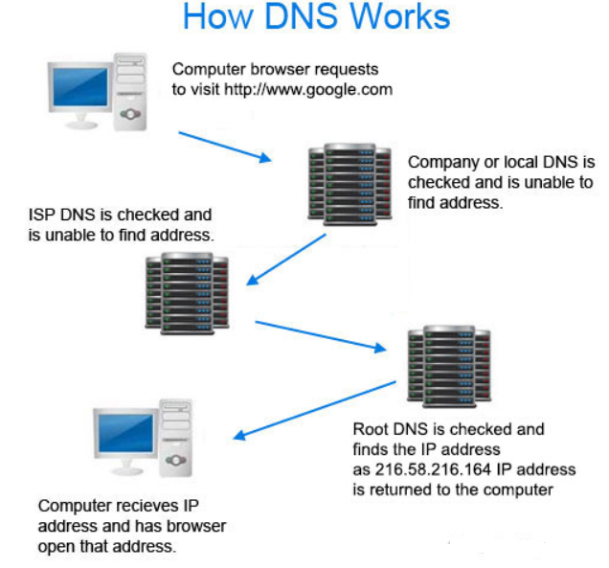

**Figure 2: How DNS works**

**Please take note:**

The DNS acronym can be used for "Domain Name System" and "domain name server" and although they share the same acronym they have different meanings. A Domain Name System is the overall system used to make a domain name an IP address as explained above. A domain name server is an individual [server](https://www.computerhope.com/jargon/s/server.htm) that is part of the Domain Name System, which may be comprised of multiple domain name servers.

**Revisiting web protocols**

We have discussed some web protocols before. Let us just run through them again.

* HTTP-HyperText Transfer Protocol.
* HTTPs- HyperText Transfer Protocol over Secure Socket Layer. HTTPS is used for personal or sensitive information for example in banks.
* For a website to use HTTPS it needs to have an SSL certificate installed on the server. These are usually issued by a trusted 3rd party, referred to as a Certificate Authority (CA).
* FTP stands for File Transfer Protocol. It is used to transfer files across the Internet. FTP is commonly used by web developers to publish updates to a website (i.e. to upload a new version of the website).
* Different protocols make use of different port numbers. E.g. port 80 for HTTP request

**Web Addresses**

An internet address of a website, file, or document in the general format  
<http://www.address/directories/filename>. Every computer connected to the internet has its unique web address, without which it cannot be reached by other computers. Also called universal resource locator or Uniform Resource Locator (URL). The URL typically points to the home page or default page (often index.html) that is located in the root folder of the website. Lifechoices is the domain. A domain is a unique name assigned to a website. Domain names are easier to remember for users than IP addresses.

An example of IP address for [www.lifechoices.co.za](http://www.lifechoices.co.za/) is 197.221.14.53

**Types of IP Address**

Many different types of IP addresses are available. Some addresses indicate a special form of communication should occur whereas others are designed to provide adequate address space for use inside a company or organization. Some are routable on the internet whereas others are not. The pattern of bits within the IP address tells the network devices how the packet should be treated. IP addresses are grouped into five classes.

Class a, Class B, Class C are commercial addresses. And are assigned to hosts. Class D is reserved for multicast use. Class A addresses are typically assigned to very large organizations. Has one octet to represent the network (NHHH) Class B is for medium sized organizations (addresses have two octets: NNHH) while Class C has three octets to represent the network (NNNH) and usually assigned to very small networks. See details in Figure 3.

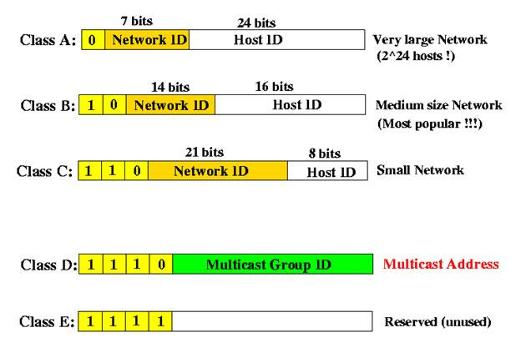

**Figure 3:Classes of addresses**

All hosts that connects directly to the internet require a unique public IP address. Private IP addresses can be used within the organizations’ themselves. There is also a private address that can be used for the diagnostic testing of devices. One such private address is known as loopback address. The Class A 127.0.0.0 network is reserved for loopback addresses.

In addition, IP addresses are also classified according to the type of the message they send. The three categories are: unicast, broadcast, and multicast address.

**UNICAST ADDRESS**

A unicast address is the most common addressing category on the network. A packet with a unicast destination address is intended for a specific host. For a unicast packet to be sent and received, a destination IP address must be in the IP packet header. A corresponding destination MAC address must also be present in the Ethernet frame header. The IP address and MAC address combine to deliver data to one specific destination.

**BROADCAST ADDRESS**

With a broadcast, the packet contains a destination IP address with all ones (1s) in the host portion. This means that all hosts on that local network (broadcast domain) will receive and look at the packet. Many network protocols, such as ARP and DHCP use broadcast. Broadcast transmission is supported on most LANs (e.g. [Ethernet](https://erg.abdn.ac.uk/users/gorry/eg3567/lan-pages/enet.html)), and may be used to send the same message to all computers on the LAN (e.g. the [address resolution protocol (ARP)](https://erg.abdn.ac.uk/users/gorry/eg3567/inet-pages/icmp.html) uses this to send an address resolution query to all computers on a LAN). Network layer protocols (such as [IPv4](https://erg.abdn.ac.uk/users/gorry/eg3567/inet-pages/ip.html)) also support a form of broadcast that allows the same packet to be sent to every system in a logical network (in IPv4 this consists of the IP network ID and an all 1's host number). See sample IP address of a broadcast addressing.

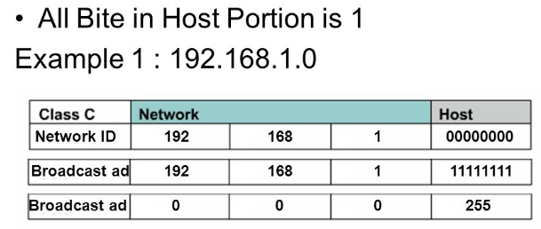

**Multicast Addressing**

Multicasting identifies logical groups of computers. A single message can then be sent to the group. Multicasting uses the Internet Group Management Protocol (IGMP) to identify groups and group members. Routers will also use IGMP to send messages to subnets that have group members. The router actually doesn't keep track of which hosts are members of which group, only that the subnet contains at least one member for each group. Each host on the network can belong to multiple multicast groups. Hosts can join or leave groups at any time. Multicast groups are identified by special IP addresses between the range of 224.0.0.0 and 239.255.255.255.

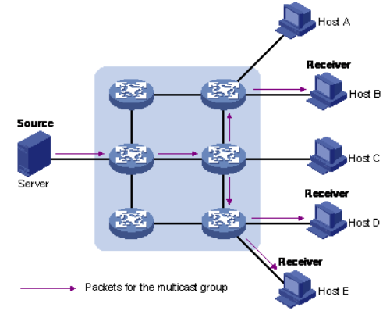

Network addresses can be assigned dynamically or statically. Dynamic allocation allows the reuse of IP addresses and allows hosts to be configured without administrator intervention. Static assignment of host IP addresses is more labour intensive but also provides the network administrator with much more control over the flow of information on the network.

**Try it out**

**List 5 website addresses of your choice. Look up for their respective ip addresses.**